**Performance Audits**

**Intro**

The following Web Performance Audit was done using **Edge’s Developer Tools**, with the *Lightroom* tab.

By performing this audit, we will be able to measure the progress of the newest version of our app against the old, as well as how our app compares to the competition, and gain some valuable insights.

**The Competitor**

*TodoListMe.net*

### Overview

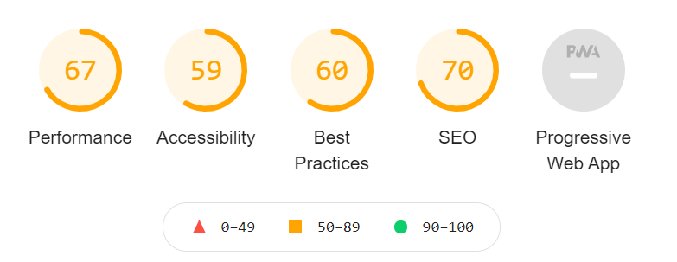

Looking at the overall audit results for the competitor, we can see that their Performance score is just fine. The other main categories are also quite low, the most concerning being Accessibility.

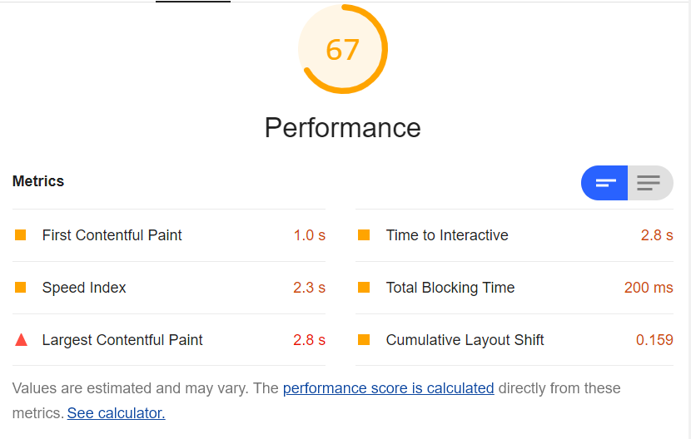

The initial thing to note here, is that **Largest Contenful Paint** does not occur until 2.8s into the load. Also, that **Time to Interactive** does not occur until 2.8s, and **Cumulative Layout Shift** taking 159ms. This is asking a lot of users, who have short attention spans and may very well leave the site before using its functionality.

### Performance

* **Texture.png** is a background image that takes 269ms to download and is barely visible. A good alternative would be to use CSS to add some interest to the background.
* **Google Ads** that take 48ms each to load are called via script tags that appear midway in the HTML file. Moving these scripts to the end of the HTML file and giving them an async attribute would allow the entire site to load prior to the ads.
* **Code-splitting** could be considered as well for both JS and CSS files. Separate the initial view and functionality into files that load immediately, moving the remainder into separate files that load asynchronously.
* **Public caching** could be used, by setting all images, icons and favicons headers to allow for public caching and also serve them in next-gen formats.
* **Minifying** the code prior to uploading to the server would make the download speed faster.

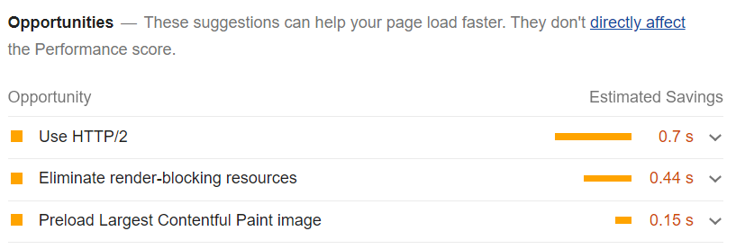

### Accessibility

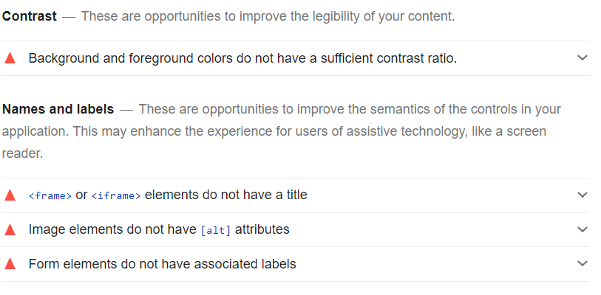

* Ensure that all images have appropriate **alt tags**.
* Make sure that the **colour contrast** has a good ratio for those with weaker eyesight or colour blindness
* Add a **title** to the frame or iframe elements

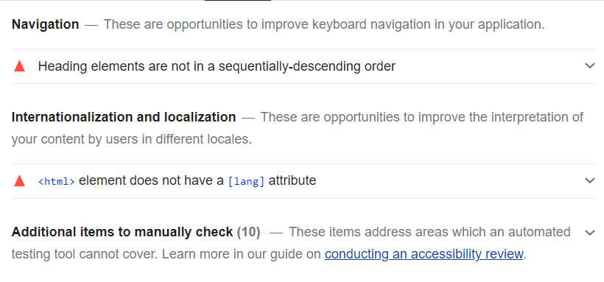

* Add a **lang attribute** to the HTML element.

### SEO

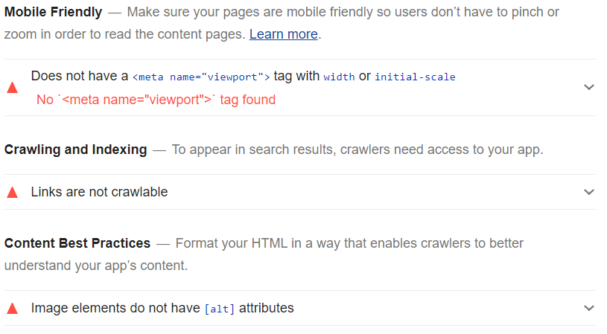

* Add a meta tag with **viewport** to the HTML head
* Add a meta tag with **keyword descriptions** to the HTML head

### Best Practices

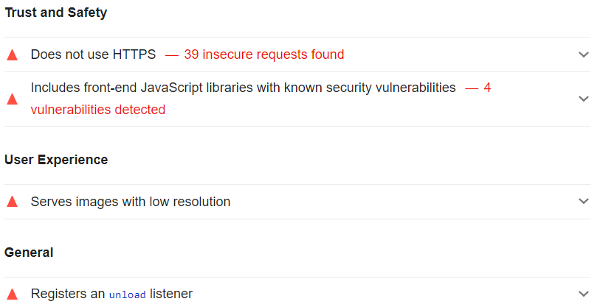

* Remove **unload listenered**
* Use HTTPS

## Summary

After making some improvements to the original version of our app, the Web Performance Audit returns an excellent score. While we can now comfortably deploy our updated app knowing that the user experience should be quite smooth, there are still some points to **keep in mind as we scale up in the future**:

* Keep all images small and serve them locally.
* Ensure that all scripts load in a logical order.
* When possible, split code and only load what is necessary in the initial render.
* Keep colour contrast on fonts high, and font size large.
* Minify large code before deployment.
* Keep up with current accessibility standards to include all users.